**> 3.28**

**> **





**> **



**> **



**> Therefore, we know that these two points are possible inflection points. We still must show that the concavity changes.**

**> **



**> **



**> **



**> **



**> We see that the concavity does change. The same result could be shown for the other value, but I will omit it in order to fit on one page.**

**3.29:**

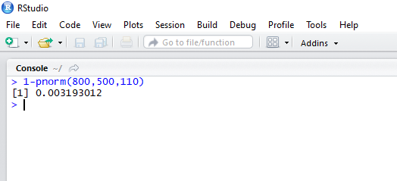

Approximately 0.32%

**3.32**

**a**. 86%

**> **



**> **



**b**. 86%

**> **



**> **



**c**. 58%

|  |
| --- |
| > punif(1/2+1/sqrt(12)) - punif(1/2-1/sqrt(12))  [1] 0.5773503 |
|  |
| |  | | --- | |  | |

**d**. 12.5%

> pbeta(1/3+2/63, shape1 = 2, shape2 = 4) - pbeta(1/3-2/63, shape1 = 2, shape2 = 4)

[1] 0.1251318